The impact of Joseph Campbel’s monomyth on modern filmmaking is a refrain in the industry. Academics use Joseph Cambpell’s theory that he established in his (1949) *The Hero with a Thousand Faces* to interpret film. Screenwriters use Joseph Campbell’s monomyth as literary devices to compose their works.

The monomyth includes seventeen archetypes. From these seventeen archetypes, for this paper I have selected these three: (1) Supernatural Aid, (2) The Ultimate Boon and (3) Apotheosis. I position these archetypes in such a way to interpret the legend of the founder of the Rosicrucian tradition at the beginning of the Enlightenment Era and the Scientific Revolution in the early seventeenth century.

Similar to the way contemporary social scientists use the monomyth to profile the main protagonists in film (and fiction) using those three archetypes listed above, I profile the legend of Frater C. R.C. as captured in the *The Fama Fraternitatis Rosae Crucis* and the *Confessio Fraternitatis*.

After establishing how archetypes apply to legend, I then replace monomyth archetypes with the archetypes of the *Major Arcana*. And instead of using the *Fama* and the *Confessio*, I apply tarot archetypes to St. Paul in the *New Testament*.

I begin by interpreting the origins of the Rosicrucian tradition using the monomyth.

*The Fama Fraternitatis Rosae Crucis* was a manuscript published in 1614 in Germany by a mysterious group of intellectuals which drew much sensational attention among their peers across Europe. Using allegory and parables, the manuscript documents the journey of their founder going by the initials “C.R”. A year later in 1615 the same group published a second manuscript, titled *Confessio Fraternitatis*, further reflecting esoteric legend and wisdom.

The monomyth is clearly and distinctly present in both.

**SUPERNATURAL AID**

In his research on myth, according to Joseph Campbell, an elderly figure like a wise man can initiate or help set into motion the hero’s adventure. It is this elderly wise man who aids or lures “the inno­cent soul into realms of trial” (1949: 60). For Joseph Campbell the teachers are mythical.

In the legend of the *Fraternitatis*, in his youth, Frater C.R.C. encounters the elders of Damcar in Arabia. These anonymous Wise Men - - perhaps Zorastrian or Sufic - - guided him in his youth. They were mysterious yet they worked wonders and miracles. According to the authors of the *Fama*, Frater C.R.C. “beheld the great wonders they wrought, and how Nature was discovered unto them” (PFC, TIRO: 8 - - Fama - - second page - - proper reference needed) He learned, studied and discovered both the supernatural and natural ways through these Wise Men. The elders and teachers in Damcar introduced Frater C.R.C. to hidden knowledge and insight. In this way, Frater C.R.C. received help and guidance from among the supernatural. This whole legend of the *Fama* is supernatural and mystical. In this way, Joseph Campbell’s archetype of “Supernatural Aid” is present in the *Fama*.

**THE ULTIMATE BOON**

In myth, it is the hero retrieves “the liquor, the milk, the food, the fire, the grace, of indestructible life.” (Campbell 1949: 149) and who then returns home with this gift. Joseph Campbell defines this archetype as the “The Ultimate Boon”.

For Rosicrucians, their fruit or pearl or gift is their agreed upon guide or instruction - - their “Axiomata” (PFC, TIRO: 11-12). To paraphrase, the first resolution is to be kind as magicians and invoke the mysterious forces of the universe for good in service to the public and at no cost, for free. The second axiom suggests blending in a healthy respect for the traditions that you are born into as well as the honour the traditions that you encounter on your travels - - both material (clothes) and immaterial (sacred prayer). The authors of the *Fama* also advise here to remain invisible and blend in. These axioms, among the four others, are the ultimate gift to their successors in subsequent centuries. Here Joseph Campbell’s The Ultimate Boon is evident.

**APOTHEOSIS**

To capture the archetype of “apotheosis,” Joseph Campbell cites Carl Jung’s alchemical principle of “mysterium coniunctionis” (or the mystery of the great union). The great union is a recurring theme abundant in the artwork and traditions of the Orient. Joseph Campbell notes this principle is apparent in “Astride Siva Siva” (included on the next page to the right) and in various similar Indian paintings of Kali. Joseph Campbell observes,

Kali shown standing on the prostrate form of the god Shiva, her spouse. Kali brandishes the sword of death, i.e., spiritual discipline. *The blood-dripping human head tells the devotee that he that loseth his life for her sake shall find it. The gestures of "fear not" and "bestowing boons" teach that she protects her children,* that the pairs of *opposites* of the *universal agony* are not what they seem, and that for one centered in eternity the phantasmagoria of temporal "goods" and "evils" is but a reflex of the mind—as the goddess herself, though apparently trampling down the god, is actually his blissful dream.

(Campbell, 1949: 146, emphasis mine)

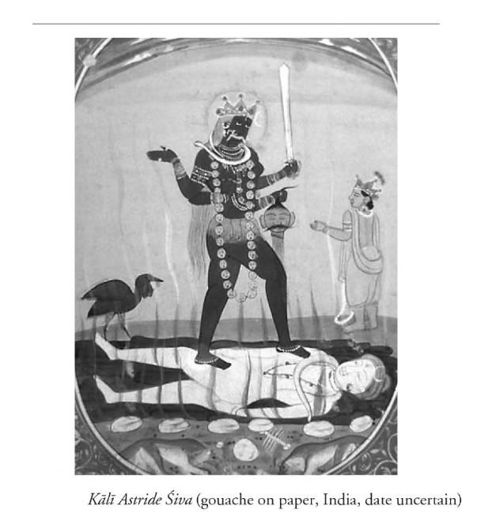

In Joseph Campbell’s assessment above, there is:

* a teacher-student dynamic,
* grand insight involving the unity of nature
* the reconciliation of opposites, and
* a blood sacrifice,

As it applies to the Rosicrucians, it is Frater C.R.C. who protects and cares for his children. The *Fama* concludes with the latin phrase: “Under the shadow of your wings, Jehovah”. In the Masonic painting titled “The Jewel of the Rose Croix” by John Augustus Knappthe, there is a motherly pelican nurturing and feeding her children under her wings. Students of the Western Mystery Tradition look up to Frater C.R.C. as a teacher or benevolent authority figure. In the same way that Christ and the prophets - - including St Paul the Apostle - - shepherd their flocks, Frater C.R.C. mentors and guides all of his students the way the pelican cares for her children.

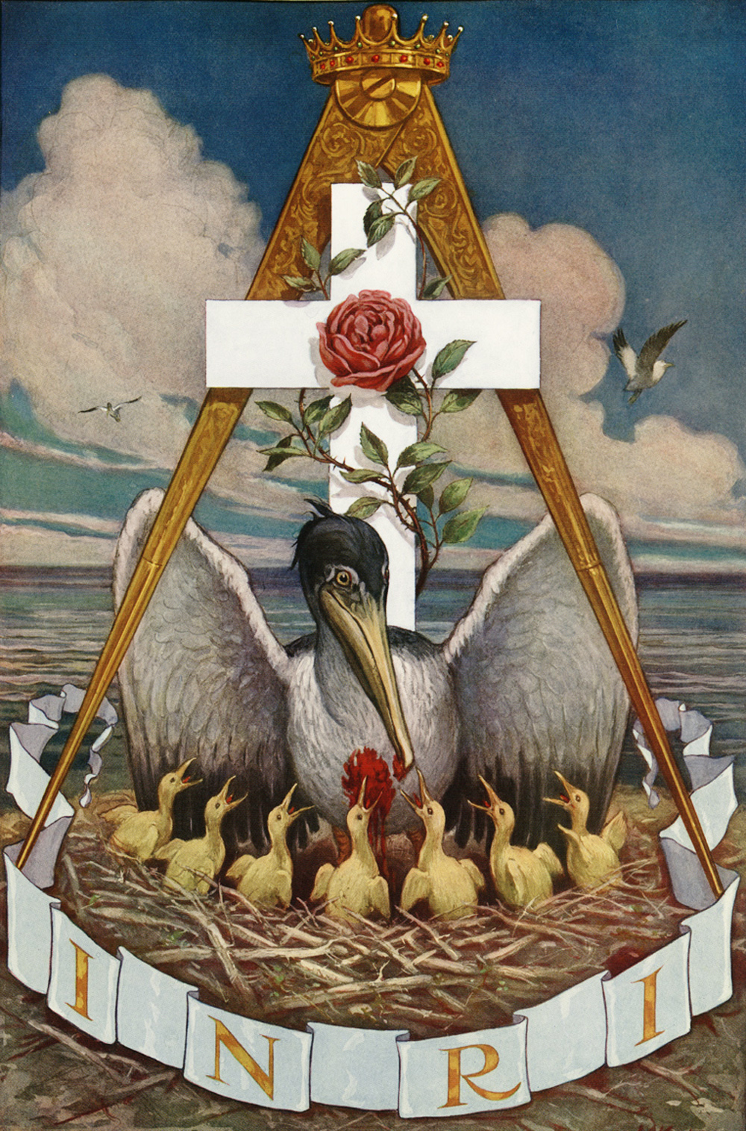

As Kali brandishes “sword” of “spiritual discipline” (as Campbell observes above) students of the Rose+Croix pursue esoteric wisdom with zeal and discipline, committed to the alchemical agenda of reconciling good and evil.

Just as there is a blood sacrifice in “Astride Siva Siva”, there is a clear blood sacrifice in “The Jewel of the Rose Croix”. In John Augustus Knappthe’s painting, INRI appears at the bottom which is a Latin phrase that could be translated into English representing: “In Death I Am Reborn Intact and Pure”. Through the death and sacrifice, Frater C.R.C. achieves immortality - - perfectly matching Joseph Campbell’s archetype of “apotheosis”.

Supernatural Aid, The Ultimate Gift and Apotheosis are clearly manifest in the *Fama*.

Addressed to the learned of Europe, Frater C.R.C. and his inner circle issued *The Confession of the Rosicrucian Fraternity* declaring their purpose and intention. They aligned themselves with Lucifer. Understanding full well that it was a capital offence against the Roman Inquisition to say so, Frater C.R.C. called the Pope “Antichrist”. Likewise, over the centuries, the Vatican has repeatedly decreed that membership in Masonic societies constitutes grave sin and Catholics who identify with Freemasonry may not receive Communion (according to the Congregation for the Doctrine of the Faith from 1983).

Despite their seemingly antagonistic orientation against one another, the Catholic story of St. Paul and the markedly Hermetic story of Frater C.R.C. share many common characteristics. As I see it, both stories involve travelling heroes who deliver on God’s covenant, who are aided by the supernatural, who speak in tongues, who establish enduring legacies and who invite outsiders into their mission while impacting a lasting lineage for centuries to come.

The purpose of this exercise (where I apply the monomyth to the *Fama*), is to demonstrate how to apply theory to legend . The pattern is similar for the remainder of this essay, except instead of the monomyth like I did above, now I turn to using tarot. And instead of the Fama and the Confessio, I use the New Testament.

The remainder of this essay is an investigation where I deploy an esoteric narrative (where I use the *Major Arcana*) to interpret St. Paul’s Apostolic scriptures.

I begin with a summary and preliminary introduction to *Luke*, *Acts* and *the Pauline Epistles*.

**BIBLIOGRAPHY**

Campbell, Joseph (1949) *The Hero with a Thousand Faces* (Novato, California. The Joseph Campbell Foundation)

Case, Paul Foster (1985) *The True and Invisible Rosicrucian Order* (Boston: Builders of the Adytum)

(1614) Fama Fraternitatis Rosae Crucis

(1615) Confessio Fraternitatis